**CD LAB 12 – POSTFIX & PREFIX NOTATION**

**Aman Kalla**

**RA1911003010640**

**CODE:**

OPERATORS = set(['+', '-', '*', '/', '(', ')'])

PRI = {'+': 1, '-': 1, '*': 2, '/': 2}

### INFIX ===> POSTFIX ###

def infix_to_postfix(formula):

stack = [] # only pop when the coming op has priority

output = ''

for ch in formula:

if ch not in OPERATORS:

output += ch

elif ch == '(':

stack.append('(')

elif ch == ')':

while stack and stack[-1] != '(':

output += stack.pop()

stack.pop() # pop '('

else:

while stack and stack[-1] != '(' and PRI[ch] <= PRI[stack[-1]]:

output += stack.pop()

stack.append(ch)

# leftover

while stack:

output += stack.pop()

print(f'POSTFIX: {output}')

return output

### INFIX ===> PREFIX ###

def infix_to_prefix(formula):

op_stack = []

exp_stack = []

for ch in formula:

if not ch in OPERATORS:

exp_stack.append(ch)

elif ch == '(':

op_stack.append(ch)

elif ch == ')':

while op_stack[-1] != '(':

op = op_stack.pop()

a = exp_stack.pop()

b = exp_stack.pop()

exp_stack.append(op + b + a)

op_stack.pop() # pop '('

else:

while op_stack and op_stack[-1] != '(' and PRI[ch] <= PRI[op_stack[-1]]:

op = op_stack.pop()

a = exp_stack.pop()

b = exp_stack.pop()

exp_stack.append(op + b + a)

op_stack.append(ch)

# leftover

while op_stack:

op = op_stack.pop()

a = exp_stack.pop()

b = exp_stack.pop()

exp_stack.append(op + b + a)

print(f'PREFIX: {exp_stack[-1]}')

return exp_stack[-1]

expres = input("INPUT THE EXPRESSION: ")

pre = infix_to_prefix(expres)

pos = infix_to_postfix(expres)

**OUTPUT:**

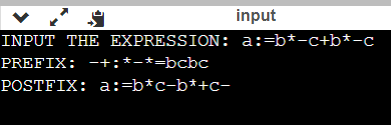

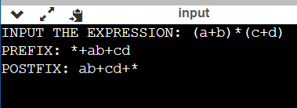

**RESULT:** Hence, the implementation of Postfix & Infix Notation is successfully done.